Is this report confidential? | No
Report of | Meeting | Date
Monitoring Officer  (Introduced by Councillor Carol Wooldridge) | Council | 22 September 2021
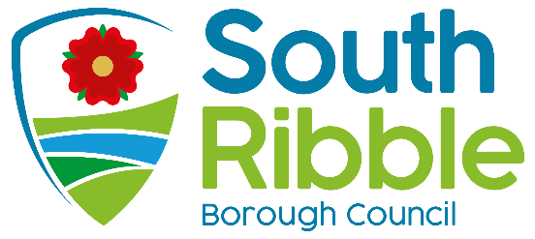

Report of the Standards Committee Hearing

Is this decision key? | Not applicable

Purpose of the Report
- On 6 September 2021, Standards Committee considered a complaint that Cllr Barrie Yates breached the Code of Conduct for Members. Members upheld the complaint and asked that the decision be referred to Full Council for information.

Recommendations to Council
- That Council review and note the complaint and the decision of Standards Committee in relation to the conduct of Cllr Barrie Yates.
- That Council support the recommendation that there be a review of the Code of Conduct for Members with an emphasis on
  - Simplifying the code and aligning with legislation the recommendations of the Office for Standards in Public Life; and specifically
  - Consideration of standardising the code of conduct across South Ribble BC and Chorley BC.
- That the Monitoring Officer be tasked with establishing a cross party and stakeholder working group to undertake the review and for the working group to present recommendations to Council for consideration and if approved adoption in due course.

Reasons for recommendations
- Having upheld the complaint, Standards Committee considered appropriate actions based on the breaches. This included reporting the matter and decision to full council.

Other options considered and rejected
- Not relevant

Corporate priorities
- The report relates to the following corporate priorities: (please bold all those applicable):

An exemplary council | Thriving communities
A fair local economy that works for everyone | Good homes, green spaces, healthy places

Background to the report
- The Standards Committee considered a complaint into the behaviour of Cllr Barrie Yates at a Planning Committee on 17 December 2020.
- Standards Committee met on 6 September 2021 and received a report from the investigating officers and representations from Cllr Yates through his representative. Having considered the repot and representations, the Committee made a number of findings of breaches of the Code of Conduct for Members by Cllr Yates.
- Attached to this report is the decision of the Committee with findings of fact and sanctions to be imposed to address the behaviour.
- Council is asked to note the decision and sanctions. In particular Council should note that the Standards Committee felt it appropriate to bring this matter before Council as the incident complained of took place at a public meeting and felt it was important that the public see and understand the resolution of the complaint.

Climate change and air quality
- The work noted in this report does not impact the climate change and sustainability targets of the Councils Green Agenda and all environmental considerations are in place.

Comments of the Statutory Finance Officer
- There are no financial implications as a result of the recommendations in this report.

Comments of the Monitoring Officer
- There are no comments on this report which is presented to Council after a decision of the Standards Committee.

Background documents
There are no background papers to this report.

Appendices
Appendix A Decision of Standards Committee Dated 6 September 2021.

Report Author: | Email: | Telephone: | Date:
Chris Moister (Director of Governance) | chris.moister@southribble.gov.uk | 01257 515160 | 14 September 2021

